Power Point Tutorials


Items highlighted in yellow are tasks for you to complete
Items in Blue italics are help tips

These pages are designed to show you how to use software packages; various software updates may have taken place so some pages will not apply to versions other than those listed here. In some cases data files may be required.

Worksheet

MPP113 Working with Slides and Text

PowerPoint has some great features that make it very easy to create great looking presentations. Text can be easily formatted and moved around. PowerPoint even has a spell checker for error free text.

In this section you will

- Add a New Slide
- Delete Slides
- Enter Text
- Edit Text
- Format Text
- Promote and Demote Bullet Items
- Set Paragraph Spacing
- Check Spelling
- Copy and Move Text
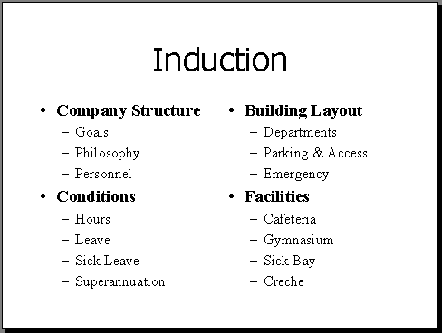
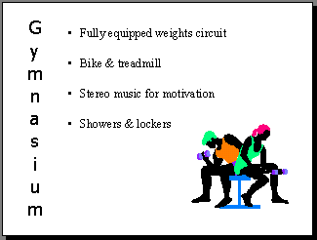
- Change the Layout of Text

Add a New Slide

A new slide can be added at any time into a presentation. When a slide is added it is inserted directly after the slide currently selected.

- You should still have the file Introduction to PowerPoint open from the previous chapter

- Ensure you are in Slide view - Click on at the lower left of the screen
- Click on the New Slide button

The New Slide window will appear as shown below with suggested layouts. When you want to create a new slide you can use AutoLayout to pick the basic setup. The layouts are shown below. You can make additions to the slide setup later on if you need to.

- Scroll through the layouts, click on the Bulleted list layout as shown below
- Click on OK to display the new slide

Selected Slide
Name of Layout

The slide layouts available are just various combinations of the objects available to PowerPoint. Some of the layouts are shown here.
Title
Bulleted Text
Table
Chart

Organisational Chart
ClipArt
Object - eg Excel Spreadsheet

Practice : Adding a New slide

- Repeat the process to add new slides with the following layouts

- Title Slide

- Text & Clipart

- Two slides of your own choice

The new slides will appear. All we need to do now is add the text. Before we do this we will look at deleting slides.

Deleting Slides

We will now delete the two slides you chose to add (Sorry!)

NOTE : You must have at least two slides in a presentation to delete a slide.

- Use the scrollbar to display the slide to be deleted on the screen
- Click on Edit in the Menu Bar
- Click on Delete Slide in the Edit Menu

The slide will disappear.

- Repeat for the second slide you chose

Entering Text

Areas where text can be entered are outlined. This outline is called a Placeholder - we just click into the placeholder and start typing.

- Use the scroll bars to move to the slide added previously with the bulleted list layout (if not already displayed). We will enter some text to this slide.

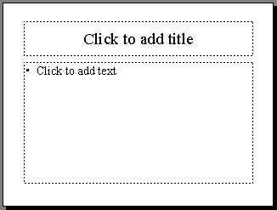
- Click into the Title box
Title box
Text box

- Type “Creche”

- Click outside the title placeholder to deselect it

The outline will disappear and the Title will be displayed.

- Click into the Text box placeholder
- Type “Open all Hours”

- Press [Enter]
- Type “Bright and Clean” and press [Enter]

- Type “Fully Qualified Carers”

- Click outside the text placeholder to deselect it

The outline will disappear and the text will appear as a bulleted list as shown to the right.

Editing Text

Editing text is easy in PowerPoint and works much the same as in Microsoft Word.

- Click into the Text box placeholder just after the word Open


The Insertion Point, (that thick flashing line at the end of the line of text) is where text is entered, or deleted.
Insertion Point

To edit text we just use the Mouse or the cursor keys on the keyboard to move the Insertion Point to the appropriate point.

Entering extra text or characters is just a matter of typing once the insertion point is in the appropriate position.

Deleting Text

⬅ Backspace gets rid of any characters before the Insertion Point (to the left)


Delete deletes characters after the Insertion Point (to the right)

To delete large pieces of text, highlight it first then use the [Delete] key.

- Use any of the above methods to edit the text in the first additional slide to read as shown below – the words to be changed are underlined

Formatting Text

Formatting text can emphasise particular points. Formatting of text in PowerPoint is much the same to other Microsoft Programs. To format a single word you need only place the mouse within the word rather than highlight the whole word. If you want to format a whole line it still needs to be highlighted.

Make sure you are in Slide View

- Check the Slide View button is on

To Change the Font of Text

- Highlight the slide title
- Click on the drop list arrow of the Font box
- Click on the desired font
- Click on the Font Size box and scroll to the desired size and click

- Experiment with other buttons along this Toolbar shown below. See if you can make the slide appear as shown above
Bold
Underline
Left or Right Aligned
Increase Font Size
Font Style

Decrease/Increase Paragrpah Spacing
Italic
Shadow
Centred
Font Size

Practice Exercises

In these exercises you will add some new slides then enter and format text.


2.1 Title Slide
y
- Add a new slide with a Title Slide layout

- Enter the text shown

- Format the text

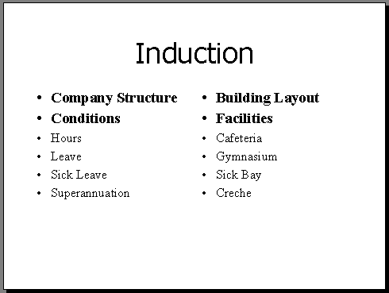
2.2 2 Column Text

- Add a new slide with a 2 Column Text layout

- Enter the text shown

- Format the text

2.3 Text with ClipArt
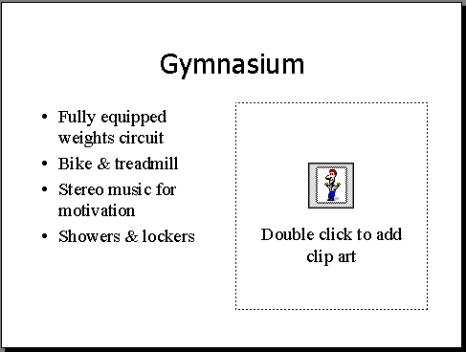
- Add a new slide with a Text & ClipArt layout

- Enter the text shown

- Format the text

(The ClipArt will be inserted later)

Promoting or Demoting Bullet Items

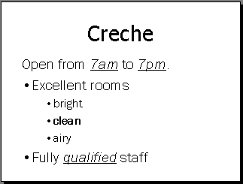
Points of text can be demoted (indented), this will result in a minor change in the size of the bullet and the text. A bullet can also be removed completely.
Bullet removed
Demoted points

You are going to make changes to the Creche slide so it appears as above.

- Display the slide with the Creche title on the screen
- Edit the second point to read Excellent rooms bright clean airy
- Move the mouse to the start of bright and click
- Press [Enter] to start a new line
- Repeat for each of clean and airy
Now you will indent each of these characteristics
- Move the mouse to the start of bright and click
- Press the [Enter] key
- Press the Demote button on the Toolbar twice

The bright point will be moved in and now with a smaller bullet and smaller text.

- Repeat for each of the characteristics

Your slide should be similar to the slide above.

To Remove Bullets

Bullets can be removed from a list item if required.

- Click on the first point “Open from …..”

- Click on the Bullet button to turn the bullet off

Practice Exercise

2.4 Indenting Bullets

- Display the slide created earlier or add a new slide and enter the following text
- Use the Demote button to create the structure shown
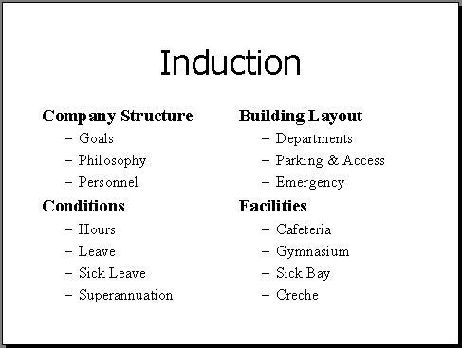
- Remove the bullets from the main points

Paragraph Spacing

The spacing of lists of text can be altered quickly using the Increase Paragraph Spacing and Decrease Paragraph Spacing buttons.

- Display the Custom Animation slide
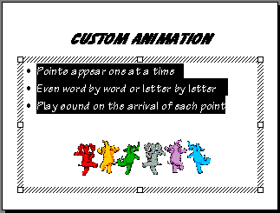
- Highlight the three lines of text

- Click on the Increase Paragraph Spacing button
The text will be spaced further apart. The spacing is also from the top.
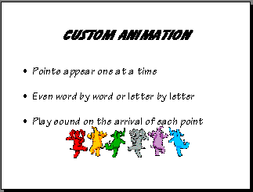

- Use the Decrease Paragraph Spacing button to move the text closer together

Spelling

PowerPoint has an inbuilt Spelling Checker to help with proofing of the presentation.

- Click on Tools ➢ Options in the Menu bar
- Click on the Spelling tab
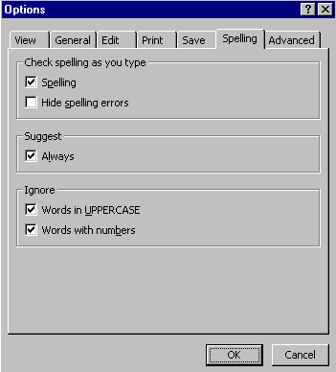
- Check the Spelling option is ticked

- Click on OK
- Add a New slide and enter the following text – red lines should appear under misspelled words to indicate incorrect spelling
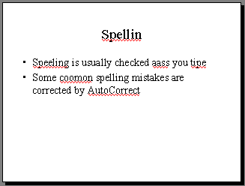

Checking Spelling

- Click on the Spelling button in the toolbar

The Spelling dialog box will appear with the first spelling mistake

- Click on Spelling in the Suggestions box to select it as the correct word
- Click on the Change button to correct the spelling on the slide

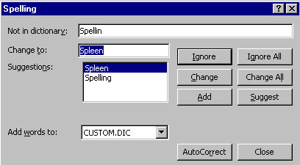
- Repeat with the next incorrect spelling of Spelling

The next incorrect spelling should be aass instead of as. PowerPoint has not suggested the correct word so it must be typed into the Change to box.

- Click into the Change to box and type as
- Click on the Change button
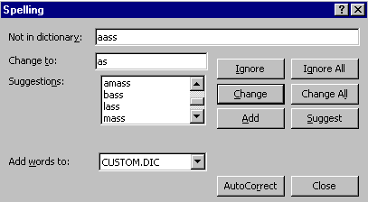
Change to:

Sometimes you will include a word that PowerPoint does not recognise. If you are sure the spelling is correct just use the Ignore button. Ignore All will ignore the spelling of this word for the rest of the presentation.

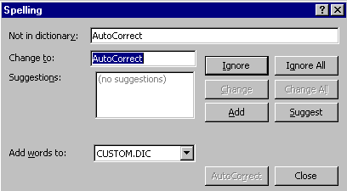
- Click on Ignore to leave the word unchanged

When the spelling check is complete you will be notified.
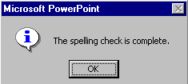
- Click on OK

The spelling in the slide should be corrected and the red lines will have disappeared.
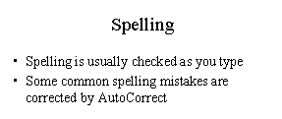

Cut, Copy & Paste

If you want to repeat or move text, ClipArt etc. to another position or slide in the presentation we can use the common Microsoft feature of Cut, Copy and Paste.

We will create a new slide and copy text from another slide to this new slide.

- Click on the New Slide button in the Toolbar
- Click on the Bulleted List layout

Copy Text

- Move to the slide with the title “Induction”
- Highlight Company Structure
- Click on Copy button in the Toolbar
- Move to the new slide just created
- Click into the Title placeholder
- Click on Paste in the Toolbar

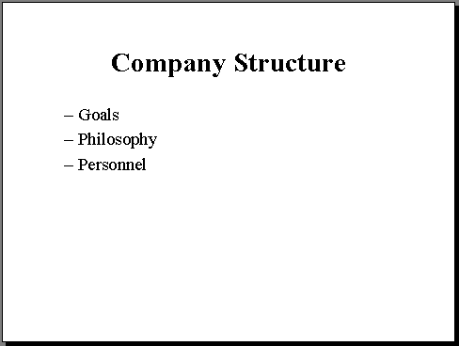
You will now have the text still in its original slide and a copy of the text on the new slide
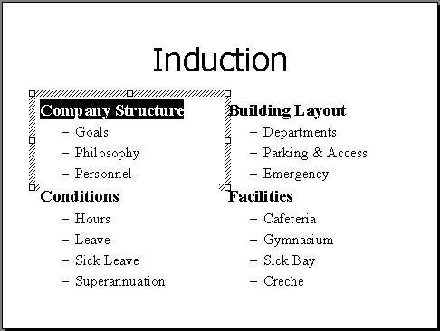
- Return to the original slide and repeat the process to copy the points for Company structure as shown above

NOTE: In this exercise you copied one line at a time for practice purposes, normally you could highlight and copy all the lines in the same placeholder at once.

To Move Text

You have decided the Induction slide is too crowded. To reduce crowding you have decided to move the Building Layout and Facilities points on another slide.

- Add a new slide with a 2 Column Text layout to house the points
- Display the slide with the title “Induction”
- Highlight just the word Building
- Click on Cut in the toolbar OR Edit ➢ Cut in the Menu Bar

- Move to the new slide you created
- Click into the Title placeholder
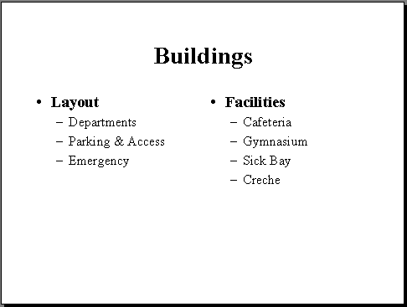
- Click on Paste on the Toolbar OR Edit ➢ Paste in the Menu Bar

- Return to the original slide and highlight the main bullet point Layout and sub points

- Move to the new slide you created

- Click into the Text placeholder
- Click on Paste on the toolbar OR Edit ➢ Paste in the Menu Bar

- Repeat the process to move the Facilities main point and sub points to the second column
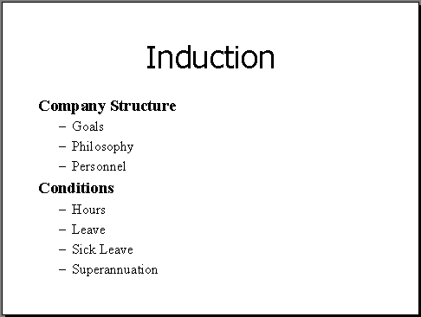

The original slide no longer displays this text. This text now only appears on your new slide.

Changing the Layout of Text

The layout of any slide can be changed to another layout using the Slide Layout dialog box.

- Display the slide with the title Custom Animation
- Click on Format ➢ Slide Layout in the Menu bar

The Slide Layout dialog box will appear.

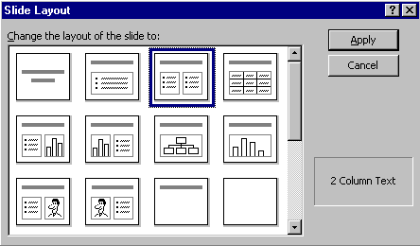
- Click on the 2 Column Text layout and then the Apply button
Apply

The original text placeholder will be moved to be the first Column of the standard layout for a 2 Column Text.
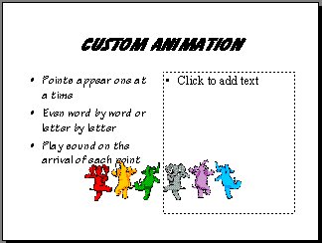

- Click into the new Text placeholder
- Type the following point
Points will dim as a new point is displayed

Customised Layout

While PowerPoint provides automatic layouts, customised layouts can also be achieved by moving the Text placeholders around and resizing them.

- Click on the Text placeholder to display the Resize handles

- Move the mouse down over lowest handle until it becomes a double headed arrow

- Click, hold and drag the handle up until the outline for the new size of the placeholder is as shown just below
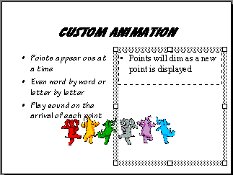
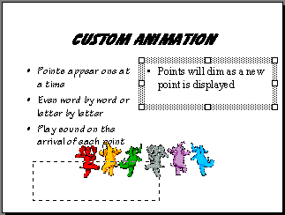
Resize Handles
- To move the text placeholder move the mouse over the border until the Move symbol appears

- Click, hold and drag the placeholder down to the bottom left corner as shown above

The text now appears in the position to which we moved the Placeholder.

- Repeat the steps above to resize the two placeholders so the text appears as shown below to the right.
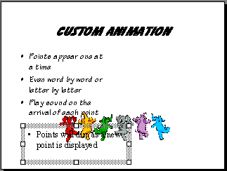
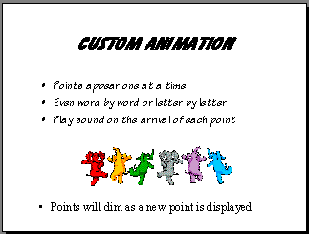
- Try changing the layout to other standard Layout options using Format ➢ Slide Layout in the Menu bar

- Change the layout using the Move and Resize techniques just outlined

Practice Exercise

2.6 Layout and Spacing

- Display the Slide created earlier that outlined the Gymnasium facilities

- Use the Move and Resize techniques to change the layout

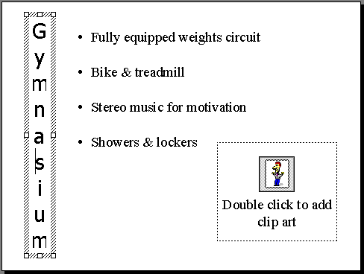
- Use the Increase Spacing button to space out the list
Hint : Change width first then height

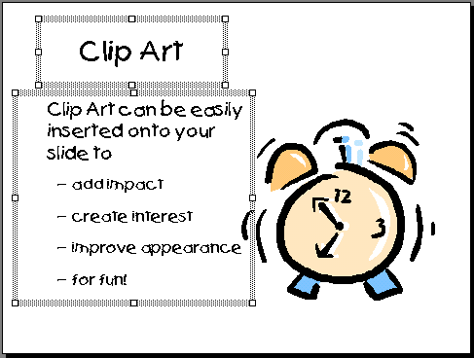
- Display the ClipArt slide and alter the layout as shown

- Leave the file open for the next section


Need help just ask

